Chapter 10, Problem 85.

Using Fig. 10.127, design a problem to help other students better understand performing AC analysis with PSpice.
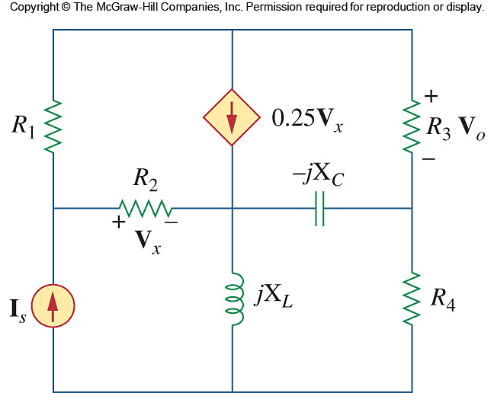

Figure 10.127
For Prob. 10.85.

